Chemtracts Example #1

**Frequency-modulated nuclear localization bursts coordinate gene regulation**

Cai, Long, et al. *Nature*. 455, 485-489 (2008).

The process of extracellular signaling, whereby the expression of target cellular genes is regulated, occurs in two stages. First, the cell translates the information from the extracellular signal to encode for the localization of specific transcription factors. Then, the transcription factors bond to their complementary gene targets, triggering a cellular response. Specifically in *Saccharomyces cerevisiae* (budding yeast), the transcription factor Crz1 is responsible for mediating the response to extracellular calcium, mainly through phosphorylation and dephosphorylation of the factor itself. The presence of an additional phosphate group on Crz1 determines whether or not it translocates to the nucleus, where it acts upon specific genomic sequences.

In their experiment, Cai, et al. aimed to elucidate the mechanism through which intercellular signals are encoded in transcription factors. In addition, they examined how the coordination of proteins during a cellular response is achieved. As their vector, they used *S. cerevisiae*, focusing on the aforementioned interaction between extracellular calcium and Crz1.

Cai, et al.’s primary mode of research was a series of time-lapse movies depicting the localization of GFP-tagged Crz1 in response to differing concentrations of calcium. This specific strain of Crz1 was obtained through the GFP carboxy-terminal protein fusion library, though all other strains were constructed similarly through the use of PCR and plasmid transformation. The time-lapse photography was conducted at room temperature, with CaCl2 (ie: extracellular calcium) added during filming. Image analysis was then performed using a Hough transformation algorithm from Matlab, with respect to the fluorescence picked up by each image.

Through experimentation, the group found that, while Crz1 remained localized to the cytoplasm in the absence of calcium, individual cells showed a synchronized burst of nuclear translocation upon the addition of calcium. Following this, the localization bursts became sporadic and unsynchronized, lasting approximately 2 minutes each on average. Cai et al. also found that varying the concentration of calcium showed a dose-dependent increase in burst frequency with an increase in calcium, resulting in a greater fraction of nuclear Crz1. Changes in calcium concentration also revealed two different modes of nuclear localization, namely an isolated burst at low concentrations of calcium (100mM) and a cluster of bursts at higher concentrations (100mM < ). Furthermore, the lowest concentrations (10mM) showed no synchronous initial response, compared to cells with higher concentrations (100mM) that consistently displayed an initial burst. Thus, the group concluded that Crz burst activity is quantized, with calcium only regulating burst frequency.

Next, Cai, et al. examined how the initial synchronized bursts were initiated, with respect to other cellular phenomena. Though their data did not suggest a role for cell-cycle regulation in the process, it seemed to indicate that intracellular calcium may play a role in burst stimulation, although it is not required. The Crz1-phosphotase calcineurin, though, demonstrated a role in frequency of burst initiation, though not in localization coordination.

Investigating the downstream effects of Crz1 localization bursts, Cai, et al. observed a distinct correlation between the bursts and a delayed burst of downstream target transcription. They then used an analytic model to show that the regulated localization bursts could allow the modulation of multiple genes simultaneously, all while maintaining a constant gene expression ratio. Upon testing the model, referred to as the frequency-modulation(FM)-coordination hypothesis, the group noted that both synthetic promoters and a large number of natural promoters changed expression by a constant factor, validating the FM-coordination mechanism.

When taken in sum, Cai, et al.’s results suggest that cellular information from extracellular events is translated through the frequency of certain intracellular events, rather than simply a change in specific molecular concentrations. This type of frequency modulation can also be seen in the macromolecular world in rocket thruster control, various signaling processes, and others. From an evolutionary standpoint, FM-coordination allows mutations in one gene’s expression to not affect the ratio in which it is produced with respect to its coordinated proteins. For this reason, and due to its prevalence in a wide variety of transcription factor networks, it is likely that FM regulation is the general mechanism used to coordinate cellular responses to extracellular signals.

Chemtracts Example #2

**Photooxidation of Cytochrome P450-BM3**

*Research by Ener, Lee, Winkler, Gray and Cheruzel*, PNAS. **2010**, 44.18783-18786

**Condensation of Research**

**Purpose of the study** *To study the electron transfer mechanism and reaction intermediates in the catalytic cycle of P450, an important biological enzyme*

**Background** Cytochrome P450 is an essential enzyme responsible for the catalysis required for metabolism of drugs, fatty acids and other substances in humans and other organisms. Because of its great importance to human health, it has been intensively studied. Despite decades of research, some of the key intermediate steps in the catalytic cycle of P450 have remained elusive.

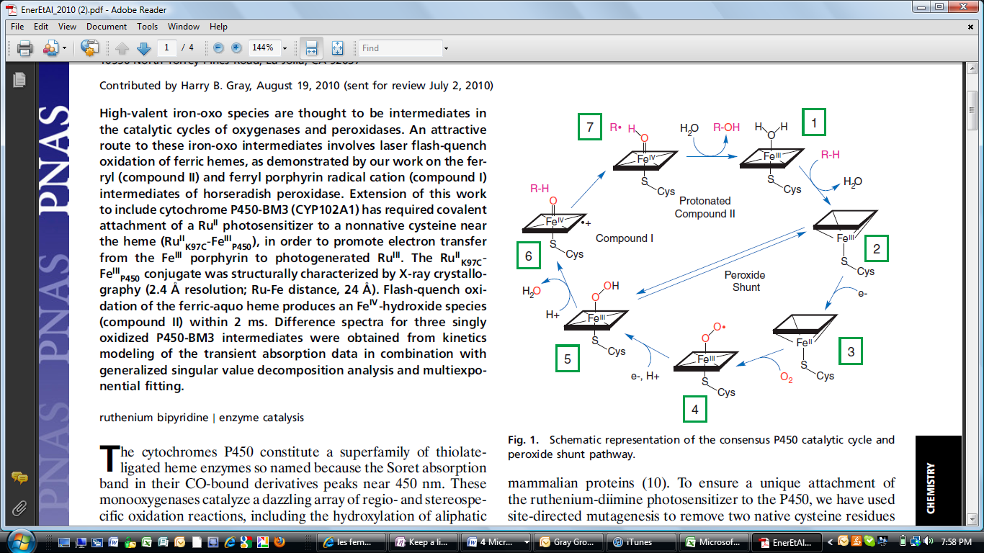During much of the time in which P450 was intensively studied, experimental methods meant to test the mechanism of electron transfer (ET) between the protein and different redox partners did not work well. Under normal conditions, it was difficult to observe the high oxidation state intermediates because the rate at which the protein and the ET reagents collided was far slower than the subsequent ET steps within the protein. In this paper, a relatively new method was used. In this method, a transition metal-centered photosensitizer is covalently bonded to a cysteine on the surface of the protein. This method allowed development of a process where the active iron site of the P450 could be oxidized by attaching the photosensitizer directly to the protein through a thioether, eliminating the slow step where the photosensitizer and protein must collide. By dramatically increasing the rate of ET from the oxidation agents to P450, the group was able to study reaction intermediates of this catalytic cycle.

With these processes, the group hoped to create better understanding of protein structure and dynamics. This understanding is necessary for better understanding of how P450s metabolize toxins, drugs, and other substances.

By running the catalytic cycle in reverse and photochemically splitting water at the heme site, they were able to obtain transient absorption data for the reaction intermediates. Through this laser flash-quench oxidation of the heme in P450, they were able to propose a catalytic cycle for the P450 (Fig 1).[1]

Figure 1: Catalytic Cycle of P450

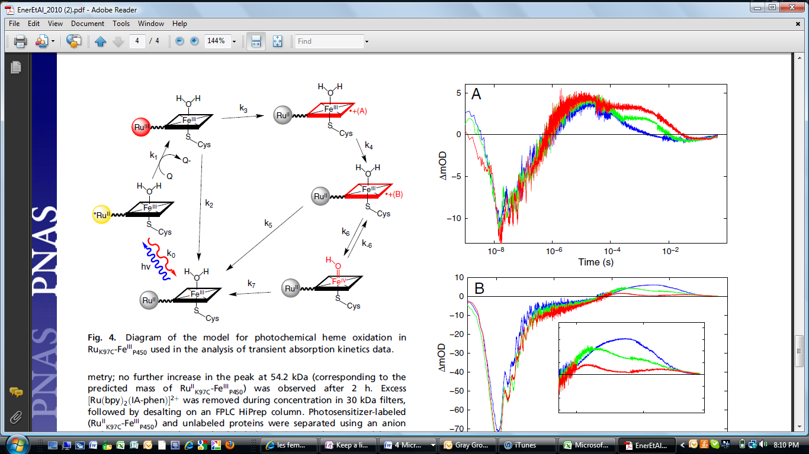

**Researcher’s Approach** In this article, the group reports the catalytic cycle for P450 as determined by a newly developed flash-quench method to oxidize the heme in the protein. After mutating and expressing the P450 protein, the group covalently attached a transition-metal centered photosensitizer to a double mutant of P450-BM3 protein. With X-ray crystal structure analysis, the group determined the distance between the photosensitizer Ru and the heme group in the protein to be 24 Angstrom.

Figure 2: Model used in analysis of TA kinetics data for photochemical heme oxidation

After this initial data collection, the group used transient absorption (TA) measurements to study the intermediates in the catalytic cycle. These measurements were repeated at the three different pH levels of 7, 8 and 9.5.

Five distinct phases were observed in the TA measurements, which the group took to suggest that six distinct species are formed beyond excitation of the Ru photosensitizer. Three of these species remain to be identified. Rates for these reactions were estimated based on the model in Fig 2.[1] Varying the pH was found to change the rate constant between the conversion of P450OX2 and P450OX3, indicating that a proton is lost in this formation process. This matches the process observed in biological systems involving P450 where the protein is able to catalyze a variety of important redox reactions.

**Commentary on the Research**

P450 is an important protein, and it is important to human health. More important, though, is understanding its mechanisms of electron transfer and, more generally, the chemical dynamics of reactions. Reaction mechanisms, and particularly catalysis, govern so much of nature and of mankind. The better we understand reactions, the more complex yet questions we will be able to ask, for example about why these reactions occur. The group was able to come up with a catalytic cycle of P450, which had been their goal in pursuing this research. The experiments were rigorously analyzed and the paper is technical, conscience, and precise.

Since having determined the catalytic cycle of P450, the group is now able to further study individual aspects of this reaction cycle. For example, the group is now beginning research on the impact of various factors into the driving force and kinetics of the individual reactions. These factors include the impact of the pH on the rates, which was already studied to some extent in this experiment, the impact of the different ligands on the photosensitizers, the impact of using different transition metal based photosensitizers, and the method of attachment of the photosensitizers to P450. Without the fundamental background reported in this paper, it is difficult to analyze these variables separately, and therefore difficult to come to a greater picture explaining the motions and changes of the molecules which govern our lives.

**References**

1. *Ener, Lee, Winkler, Gray and Cheruzel*, PNAS. **2010**, 44.18783-18786